

root@cyberster:~$ whoami
> hanzallah — soc_intern
DAY
29-30
Sample Selection,Acquisition & Enviorment Lockdown
// candidate Hanzallah
// program Cyberster — Cybersecurity Internship (Batch 2)
// tutor Abdullah Zia
[ STATUS: TASKS COMPLETE — READY FOR REVIEW ]

// 29-30 OVERVIEW & SCOPE

This phase established the malware analysis workflow for the week: selecting two samples from theZoo across different malware categories, acquiring them securely, hashing them for integrity tracking, and locking the lab environment down to an airgapped state before any analytical work begins. The sequence — connect, download, verify, airgap, analyse — was followed strictly, since acquiring samples after the network is disabled is not possible, and analysing them before the airgap is in effect is unsafe.
All work was performed on the Kali VM (192.168.56.102). The Host-Only adapter used for Wazuh agent communication was kept active throughout; only the NAT adapter was disabled to enforce the airgap.

// 01 SAMPLE SELECTION & JUSTIFICATION

Two samples were selected from theZoo, deliberately chosen from different malware categories to broaden analytical coverage across the week: a trojan (covert, persistence/stealth-oriented behavior) and a ransomware sample (destructive, high-visibility behavior). Pairing a quiet sample against a loud one gives a useful contrast for the write-up — one is built to stay hidden, the other to announce itself.
$ Sample 1 — Ransomware.Cryptowall
Category: Ransomware. CryptoWall is a well-documented ransomware family known for encrypting victim files and dropping ransom notes demanding payment for decryption. It was chosen for its extensive existing public research, which allows this analysis to be verified against known behavior.

$ Sample 2 — Trojan.Alienspy
Category: Trojan / Remote Access Trojan (RAT). AlienSpy is a cross-platform, Java-based RAT descended from the Frutas, Unrecom, and Adwind RAT lineage, supporting Windows, Linux, Mac OS X, and Android targets. Documented capabilities include system reconnaissance, keystroke logging, webcam/microphone capture, browser credential theft, remote desktop-style monitoring, and a backdoor channel for downloading additional payloads — it has been observed delivering the Citadel banking trojan in the wild. It also uses sandbox/VM detection and TLS-encrypted C2 traffic to evade analysis. Selected to contrast with the ransomware sample: where CryptoWall is loud and destructive, AlienSpy favors stealth, persistence, and long-term credential theft.

// 02 PHASE 1 — CONNECT & DOWNLOAD

With the NAT adapter active, connectivity was verified before any downloads were attempted:
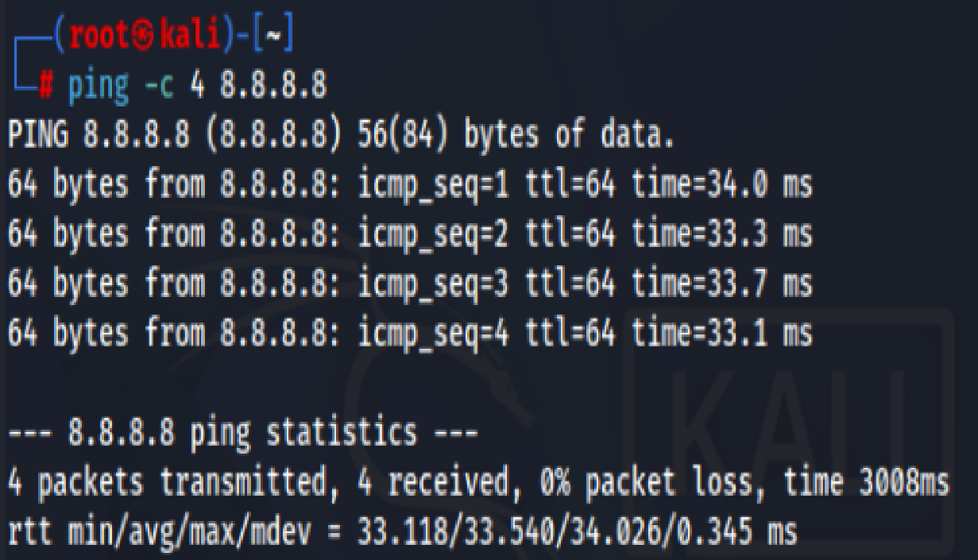
A dedicated, owner-only-readable directory was created for the samples:
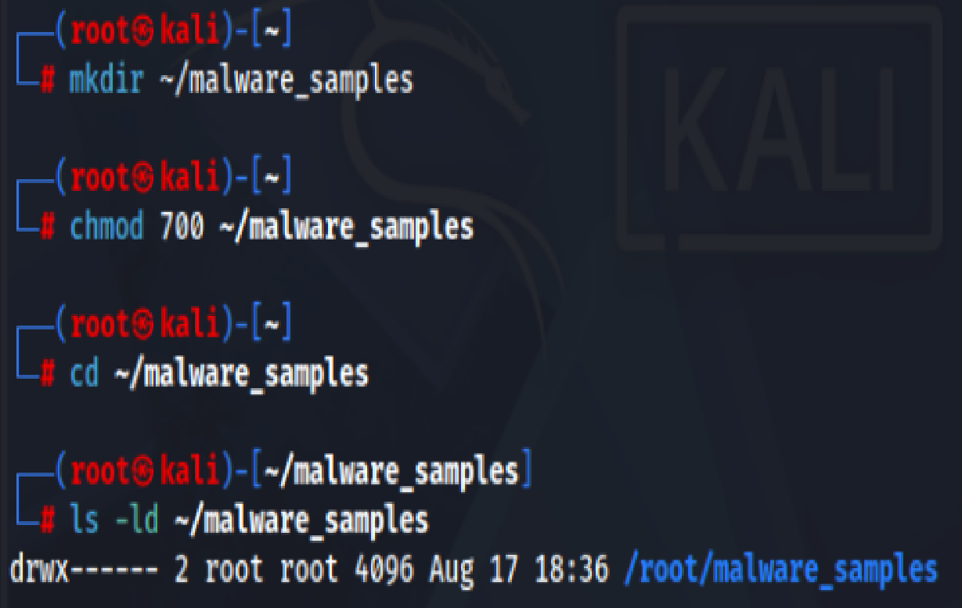
Both sample archives were acquired via direct download from theZoo's GitHub repository — not via git clone, to avoid pulling the multi-gigabyte full repository. Ransomware.Cryptowall.zip was downloaded via browser to the Downloads folder and moved into the working directory; the second sample's acquisition method should be recorded here (wget or browser).

mv /home/hanzallah/Downloads/Ransomware.Cryptowall.zip ~/malware_samples/sample1.zip
# sample2.zip acquired via: <wget | browser download — confirm>

Both archives were extracted using the standard theZoo password, and verified as non-empty:
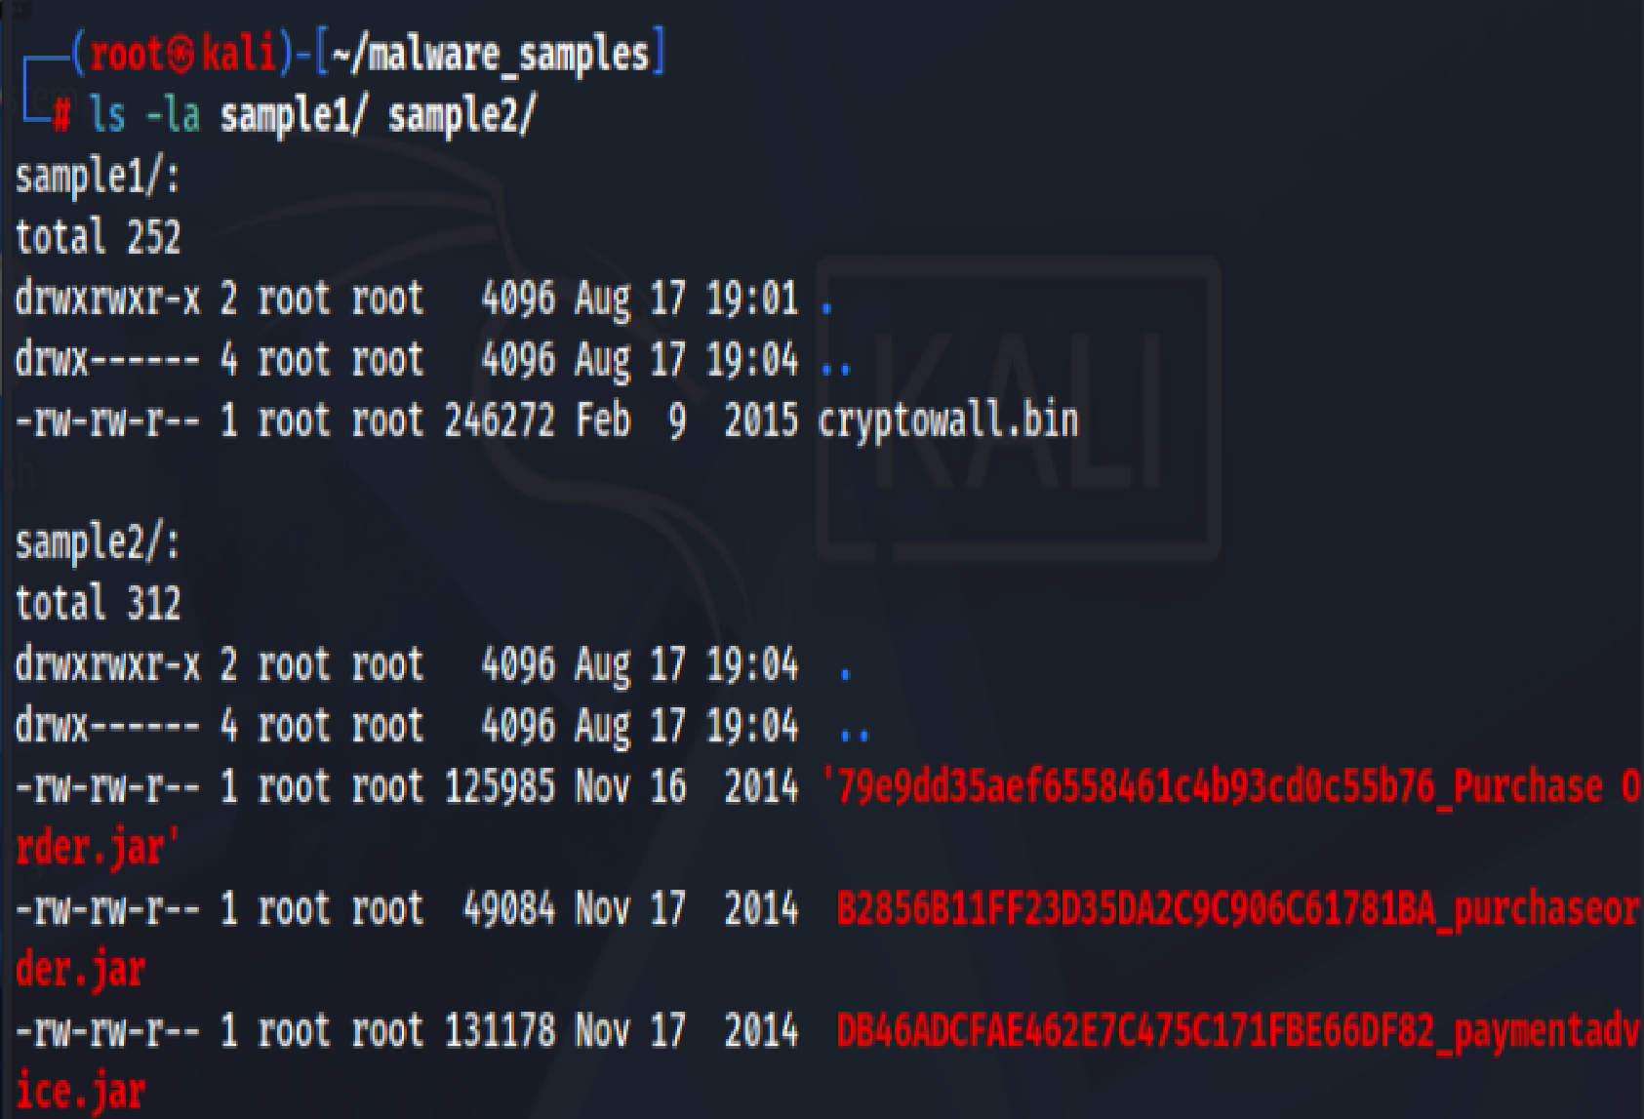
Directory listing showing both downloaded ZIPs and extracted samples with file sizes
SHA256 and MD5 hashes were computed immediately after extraction, before the samples were touched any further. From this point on, every reference to a sample in this report uses its hash rather than its filename.
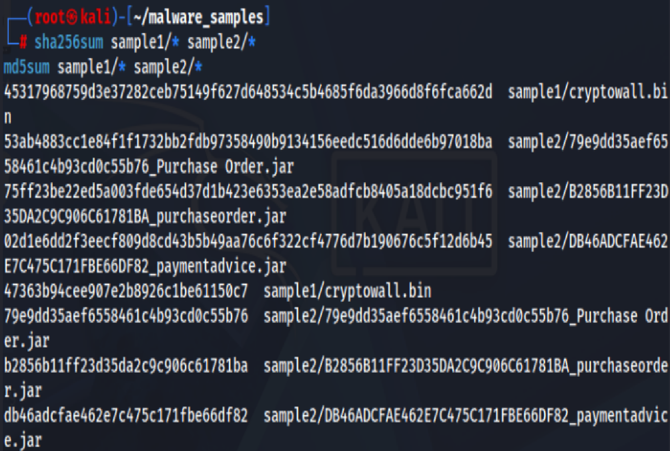
// 03 PHASE 2 — AIRGAP

With both samples downloaded, verified, and hashed, the NAT adapter was disabled through the VirtualBox Settings panel — not by bringing the interface down inside the guest OS, since that leaves the adapter live at the hypervisor level. The Host-Only adapter used for Wazuh communication was left enabled.
The airgap was confirmed by re-running the same connectivity test used in Phase 1 and verifying it now failed:
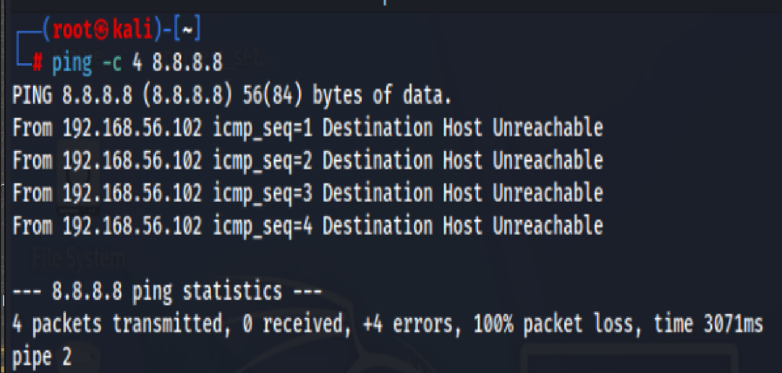
Failed connectivity test confirming the airgap is in effect

Final restrictive permissions were then applied to the extracted sample files — readable but not executable by default:

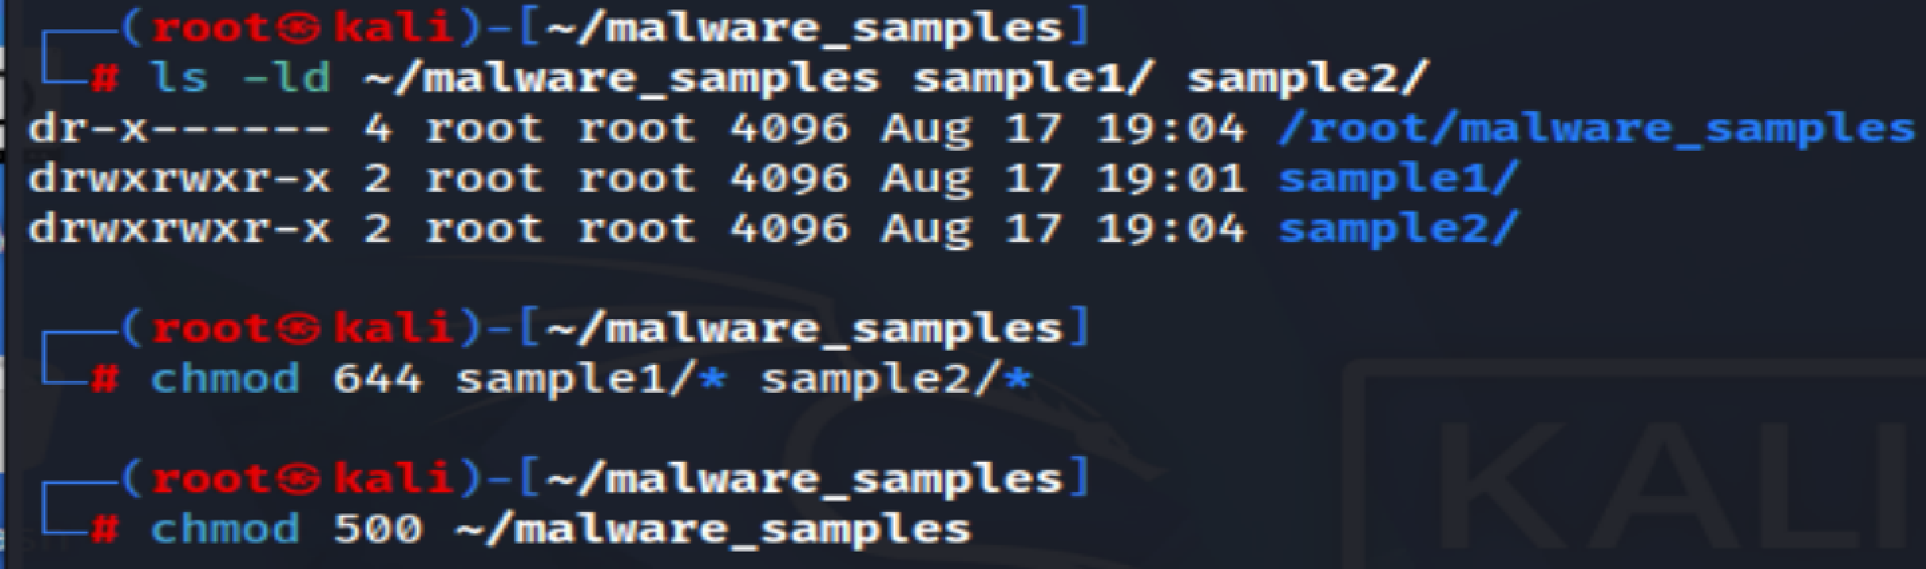
Permission settings applied to the sample files and sample directory

// 04 PHASE 3 — BASELINE CAPTURE

Before any analytical interaction with the samples, a network capture was started on the Kali VM's Host-Only interface (eth0 — the interface carrying the 192.168.56.0/24 lab network) to record normal background traffic — Wazuh agent heartbeats, ARP, and any other routine chatter — before anything unusual occurs. This baseline is the reference point used later in the week to identify traffic that is new once the samples are executed.

Result: 2,769 packets captured, 0 dropped by the kernel — a clean baseline capture.
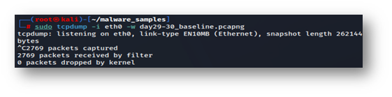
tcpdump summary confirming the baseline capture completed cleanly

// 05 DELIVERABLES SUMMARY

- Written justification for both sample choices — category and reasoning (Section 01).
- Screenshot of directory listing showing downloaded ZIPs and extracted samples with sizes.
- SHA256 and MD5 hash table for both samples (Section 02).
- Screenshot confirming the airgap — failed connectivity test with error visible.
- Screenshot of permission settings applied to sample files and directory.
- Baseline network capture file — day29-30_baseline.pcapng.

